Note: Email thread regarding Employee Review. I stopped by HR office to ask about Employee Self-Reviews (I had heard that a form was sent out and they were due back Oct 17th). Email shows I asked Thomas Phillips (supervisor) about this on the day it was due and he responded with the form. I stayed late that day to fill it out and faxed it back to him to meet the deadline that afternoon. I never heard received a response or an invitation to meet to discuss (which was protocol for other employees).
It was not until Dec 12, 2025, when in response to my email asking about the status of the review that I was invited to a performance review with Thomas Phillips, CGO and Cameron Harris, Dr of HR. That review began with formal disciplinary action. This reflects a hostile work environment and retaliation for previous reports and issue discussions. (See Exhibit Lord v CDI Audio Transcription of Review)

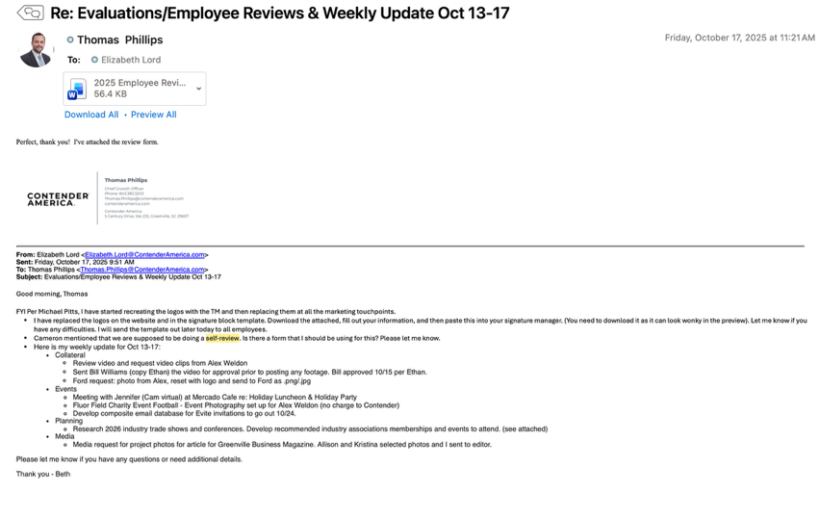
Email Dec 12, 2025 re: Performance Review from Thomas Phillips
